**Title:-Water Level Indicator with Alarm (or) Buzzer**

**Abstract:-**

Now I am going to talk about a very useful project that I had taken up. It is called the Water Level Indicator with buzzer. Nowadays everybody has overhead tank at their homes. But everyone who has a water tank above knows the kind of problem that they face. Firstly there is no system to track the water in the tank. Then there comes a secondary problem that is when their water pump is started they have no idea when it gets filled up and sometimes there are situation where the pump keeps on pumping water to the tank and the water starts spilling out from the tank. There is wastage of energy as well as wastage of water.

**eSim Required Components:-**

|  |  |
| --- | --- |
| **Water Level** | **Indicator** |
| **Component Name** | **Type** |
| BC547 | Transistor |
| eSim_Led | Led |
| pulse | pulse voltage source |
| DC | DC voltage source |

**eSim Circuit Design Screenshot:-**

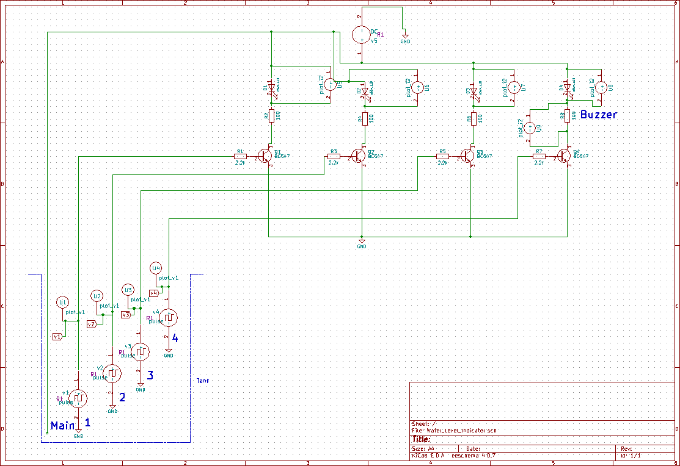

**Circuit Description:-**

We can consider this whole circuit as 4 small circuits, each one for indicating/alarming, when a particular level of water have been reached. When water level reaches to a particular level (Level 1, 2, 3) then the Led corresponding to that level (Green, Yellow, Orange) will start glowing. And finally when tank gets full (Level 4), circuit with buzzer and corresponding Led gets completed and buzzer starts beeping and Led (Red) starts glowing.

**Working of Circuit:-**

Here we are using transistor (of NPN type) as a switch. Initially there is no voltage applied to the base of the Transistors (BC547) and the transistors are in OFF state and no current is flowing through collector and emitter so LEDs are also OFF.

When the water level reaches to Point 1 in the tank, the positive side of the battery gets connected to the base of the Transistor Q1 through the water. So when a positive voltage has been applied to the base of the Transistor Q1, it gets into ON state and current starts flowing from collector to emitter and LED D1 glows (Green).

You can see resistors (R1, R3, R5, R7) at the base of each transistor, which is used to limit the maximum Base current. Generally a transistor gets its ON state fully when voltage of 0.7 V is applied to the base. There are also resistors (R2, R4, R6, R8) with each of the LEDs, to drop the voltage across LEDs, otherwise LED may blow up.

Same phenomenon happens when water level reaches to Point 2. As soon as water level reaches to Point 2, a positive voltage gets applied to the Transistor Q2, it gets ON and current started flowing through LED D2, and LED D2 glows (Yellow). With same principle, LED D3 glows (Orange) when water level reaches to Point 3 and finally D4 LED glows (Red) and Buzzer beeps when water level reaches to 4.

**Simulation using eSim:-**

I have performed the transient analysis for a stop time of 10 sec using eSim. I have used 4 ac-pulse voltage sources each having a time delay of 2 sec with respect to the previous one to indicate the water level in the tank. For the simulation of Buzzer, I have used a 100 Ω resistor. The main power supply voltage is 5V.

**Screenshots for Input Values:-**

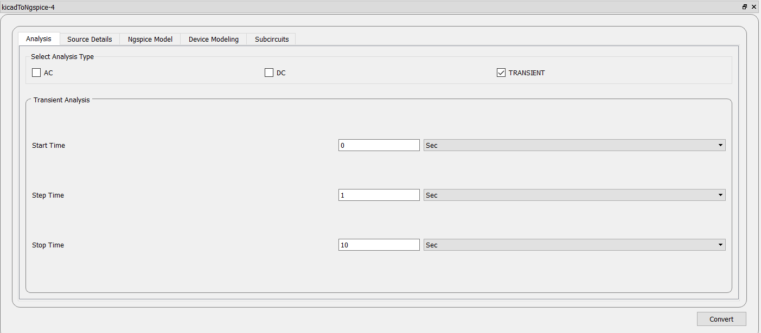

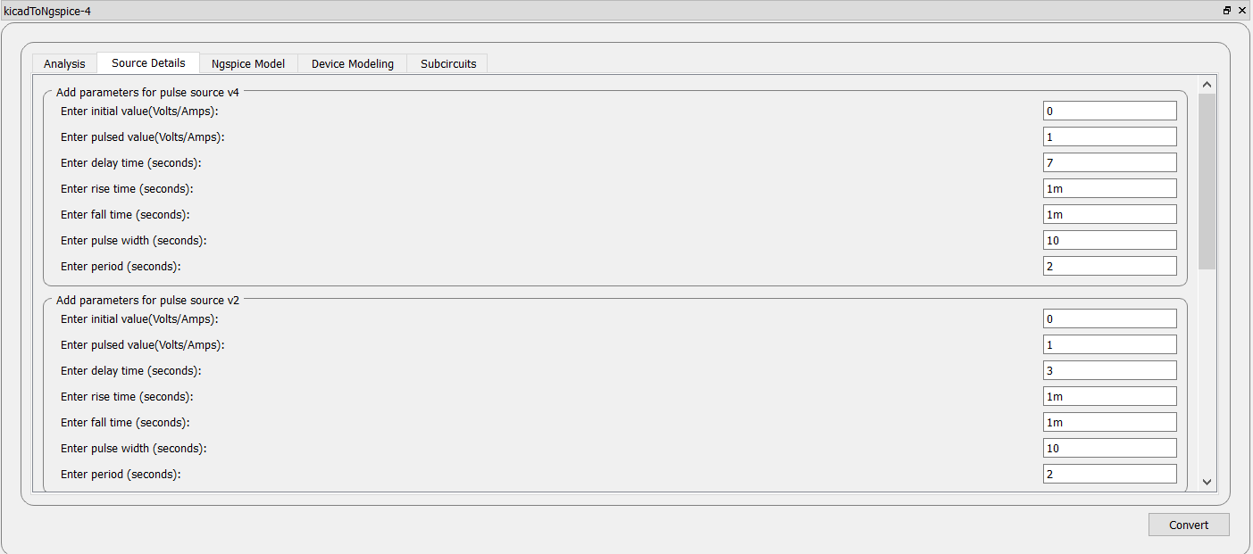

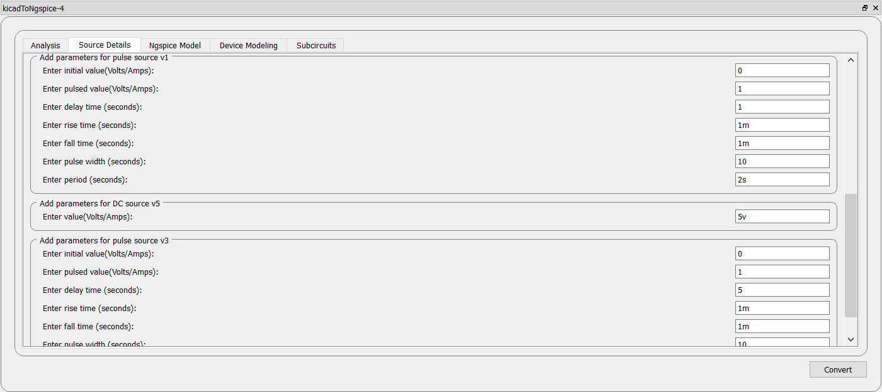

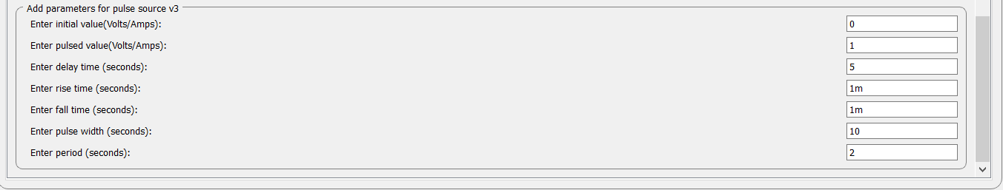

**Ngspice Graphs Screenshots:-**

**Input Graphs:-**

**1.For v1:-**

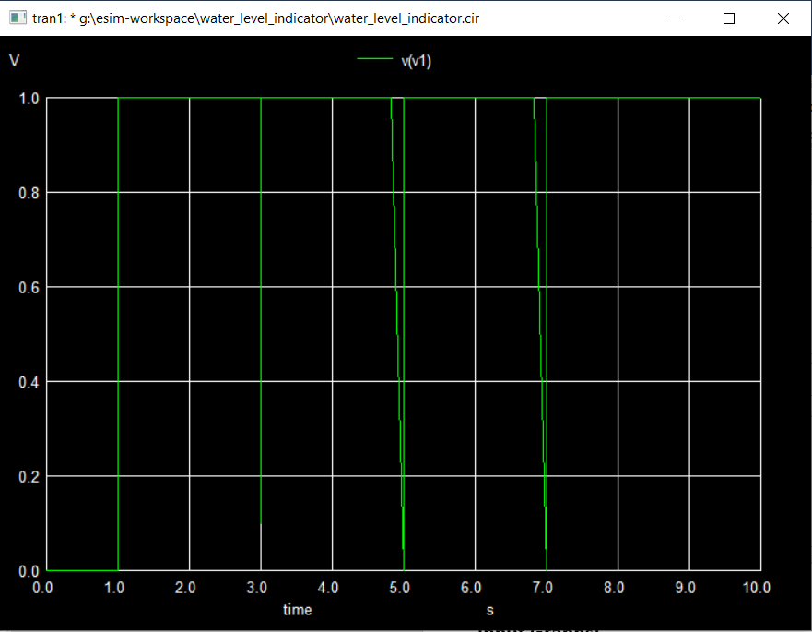

**2.For v2:-**

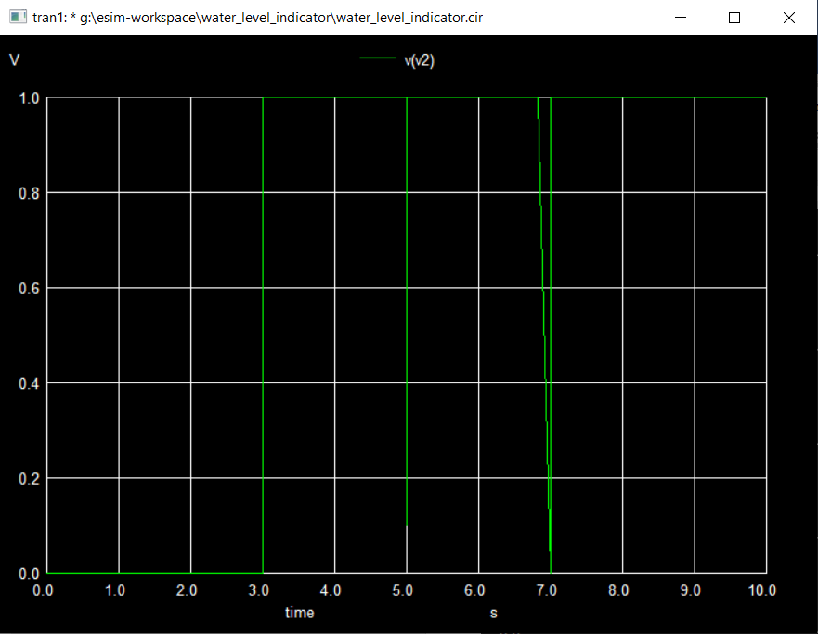

**3.For v3:-**

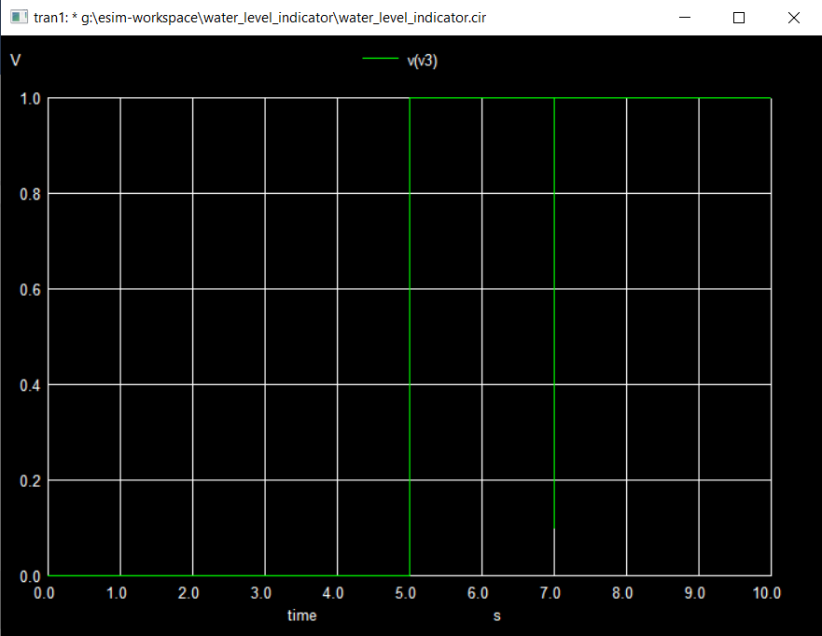

**4.For v4:-**

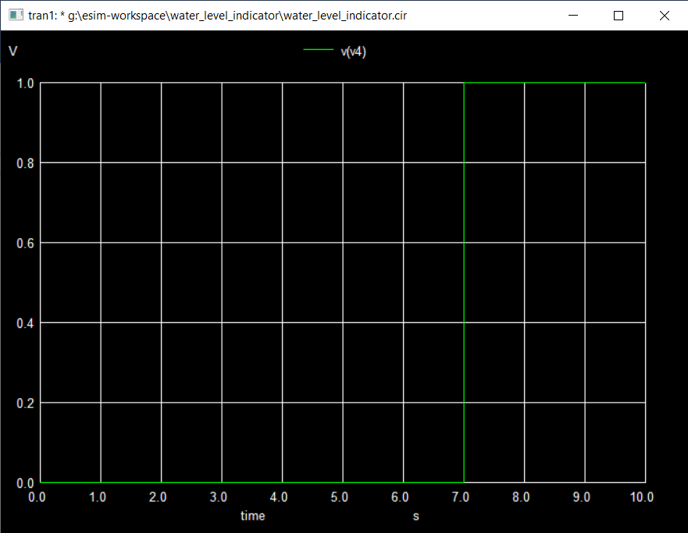

**Output Graphs Screenshots:-**

**For Led D1 (Green):-**

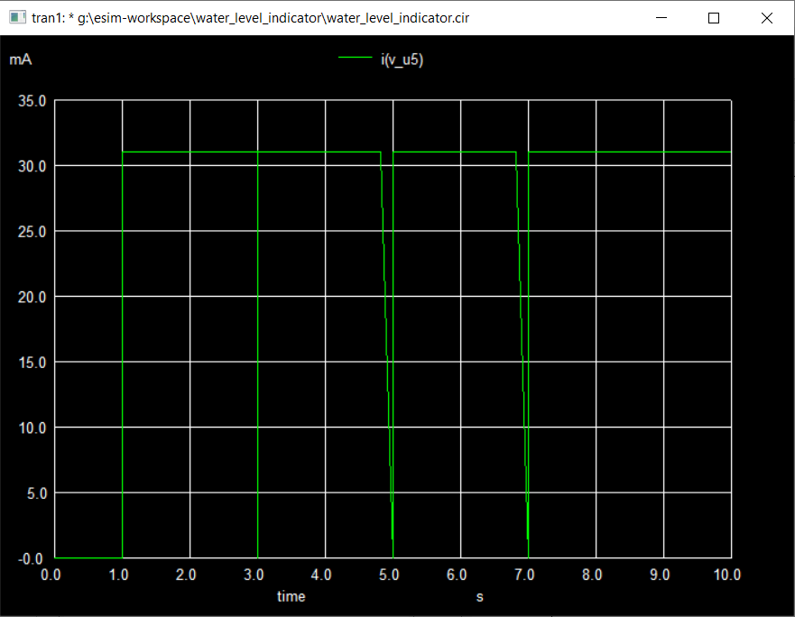

**For Led D2 (Yellow):-**

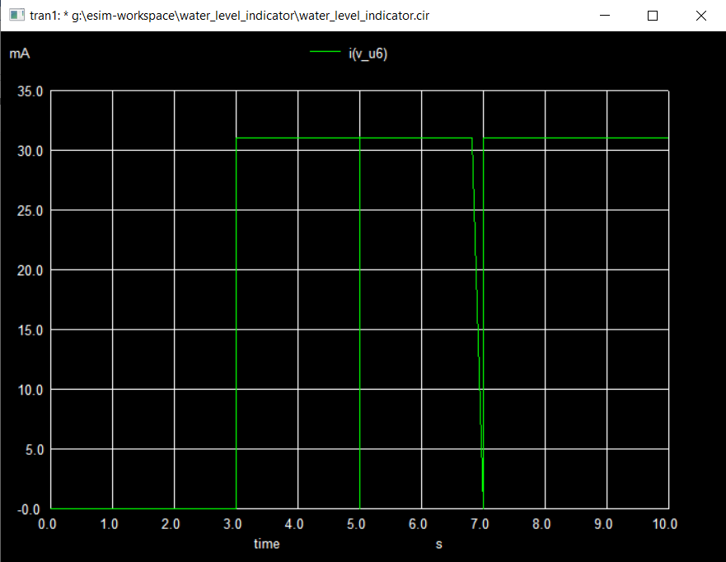

**For Led D3 (Orange):-**

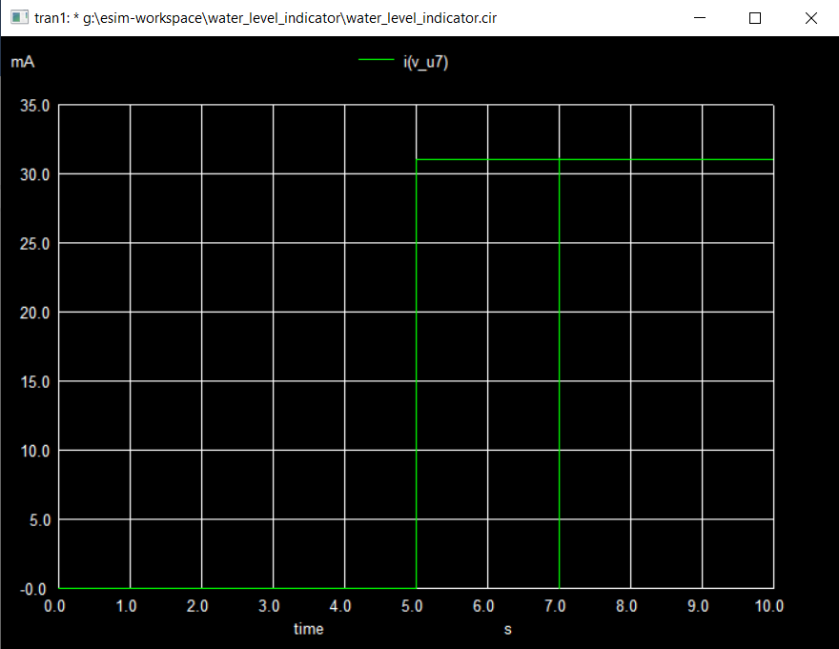

**For Led D4 (Red):-**

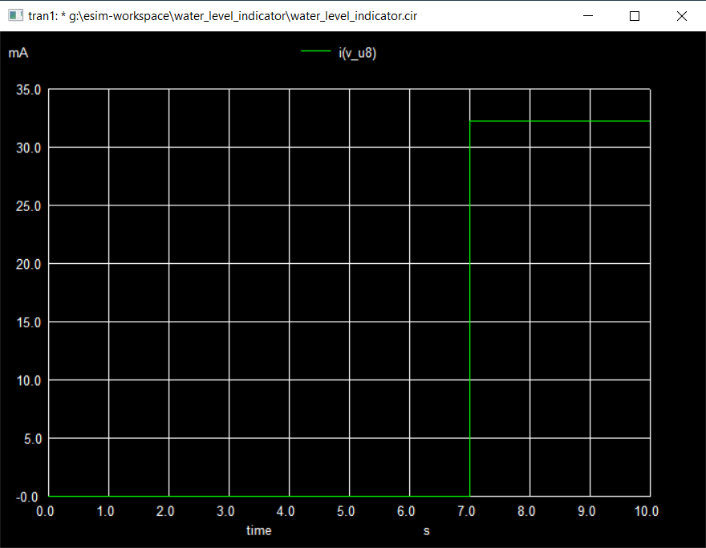

**For R8 (Buzzer):-**

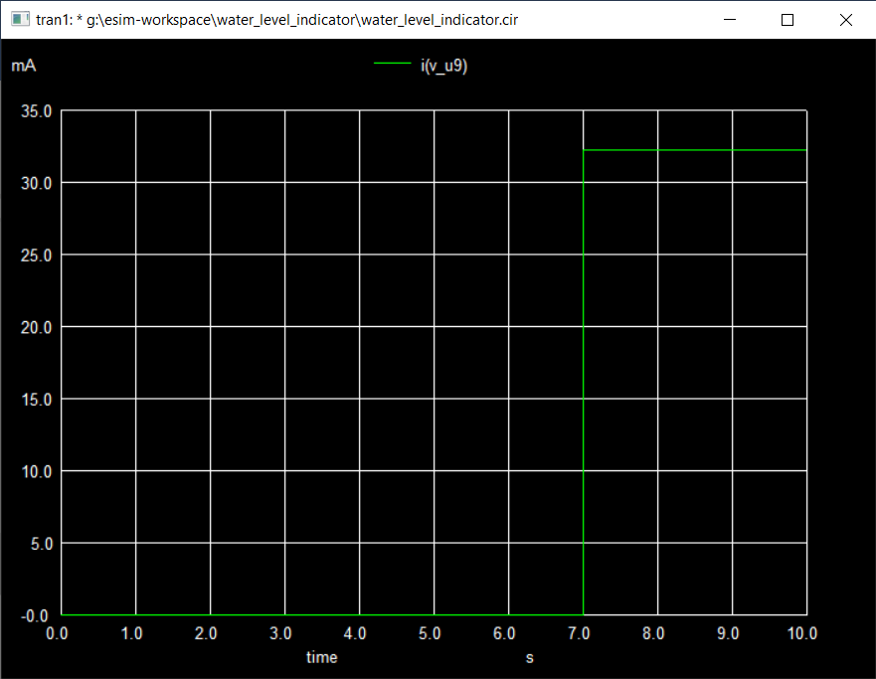

**Python Plot Graph:-**

**1.Combined Input Voltage Graph:-**

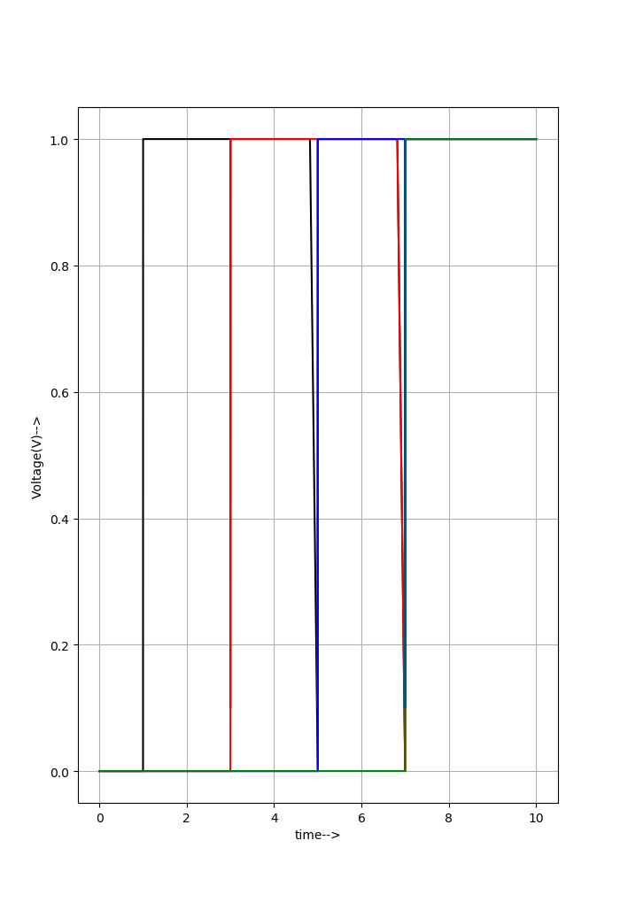

**Here**

**v1-Black line**

**v2-Red line**

**v3-Blue line**

**v4-Green line**

**2.Combined Output Current Graph:-**

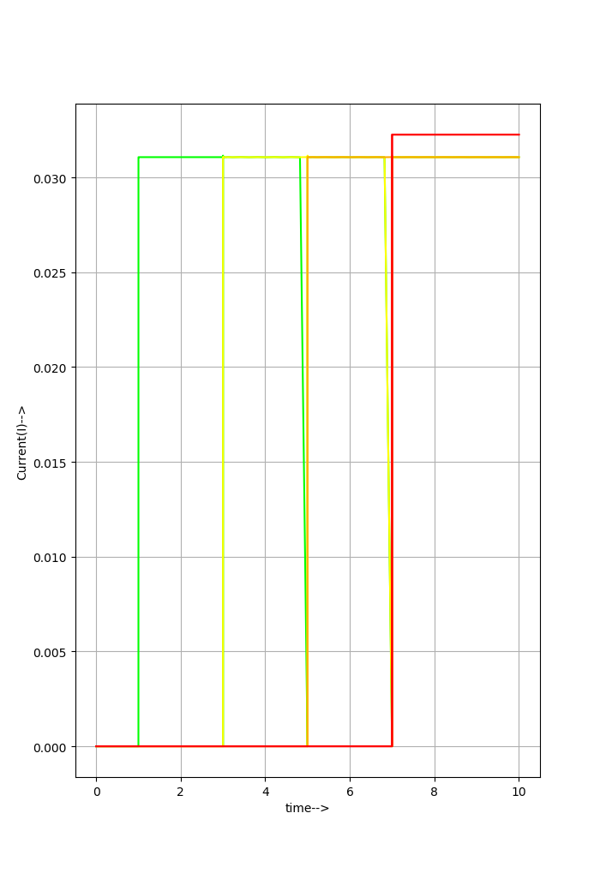

**Here**

**Led D1 (Green)-Green line**

**Led D2 (Yellow)-Yellow line**

**Led D3 (Orange)-Orange line**

**Led D4 (Red)-Red line**

**R8 (Buzzer)-Red line**

**Observations:-**

The Ngspice and Python Plot graphs displays that as the water reaches at each level after a fixed interval of 2 seconds each the current begins to flow through the LED belonging to that particular level, and therefore it starts glowing. Finally after 7 seconds when water reach to the top level the branch having buzzer and Red led becomes conducting and as a result the Led starts glowing and buzzer starts beeping.

**Observations at definite intervals:-**

**1. At t = 0 seconds:-**

Water level starts rising in the tank.

**2. At t = 1 seconds:-**

Water level reaches the 1st mark. So LED1 (Green) starts glowing.

**3. At t = 2 seconds:-**

Water level continues to rise.

**4. At t = 3 seconds:-**

Water level reaches the 2nd mark. So LED D2 (Yellow) starts glowing.

**5. At t = 4 seconds:-**

Water level continues to rise.

**6. At t = 5 seconds:-**

Water level reaches the 3rd mark. So LED D3 (Orange) starts glowing.

**7. At t = 6 seconds:-**

Water level continues to rise.

**8. At t = 7 seconds:-**

Water level reaches up to the brim. So Led D4 (Red) starts glowing and buzzer starts beeping.

The Led (Red) glows and buzzer beeps continuously until the water level reduces or the power supply is switched off.

**References:-**

* <https://circuitdigest.com/electronic-circuits/water-level-indicator-alarm-circuit>

**Done By:- P B S S Jaswanth**

**Reg No:-19MIA1039**